Refugee Crisis in Lebanon
Critical Reading and Analysis
By grade 8b

Partnership Project
April 2019

Refugee Crisis in Lebanon

Dear Danish friends,

We are a group of 4 students from Deustche Schule, Jounieh who would like to inform you about our refugee crisis in Lebanon. According to the article we have read, the situation in our country is very bad and getting worse. The number of Syrian refugees is constantly increasing and already over a million. We can assure that if war continues, the refugee crisis would lead the Lebanese economy to collapse.

Lebanon was occupied by the Syrian army from 1976 until 2005 after the assassination of Prime Minister Rafik Hariri, and then they were forced to withdraw following UN Security Council. Since 1990, unskilled Syrian workers had been in Lebanon working for their families. At the beginning of the civil war, Syrian workers brought their families to live with them in Lebanon. Syrians are not allowed to wander in the dark Lebanese streets after nightfall because of multiple security reasons, such as migrants and displeased. Some Syrians might find it hard to live here under pressure because they are illegal or because of the lack of jobs and low income. Ali Khedr says that making inhumane and unjust policies could lead to more instability and also says that what is going on in Lebanon is a smaller model of what is going on in the world.

We are worried about the refugee situation in Lebanon based on what we have read in the article because the number of these refugees is close to pass the total number of the Lebanese population and are more worried than confident to find a good solution for the crisis.

We would like to ask you a few questions guys and your answers will be highly appreciated:

- Why do you think the number of refugees is decreasing in Denmark?

- If you were in charge of the refugee situation, would you accept the refugees or reject them?

- Does Denmark provide the essentials for the refugees?

- If you were a refugee, how would you feel to be rejected?

- If Denmark accepted a lot of refugees, what would be their impact on the society?

- Do refugees really integrate in the Danish society?

- Do you think that what refugees are encountering could lead to extremism and violence?

- Do you think that refugees will consider Denmark as a substitute to their country of origin?

- Do you think that refugees will fulfill the need for plumbers and similar jobs in Denmark?

Looking forward to hearing from you!
Christopher, Andrew, Emmanuel, Marchello

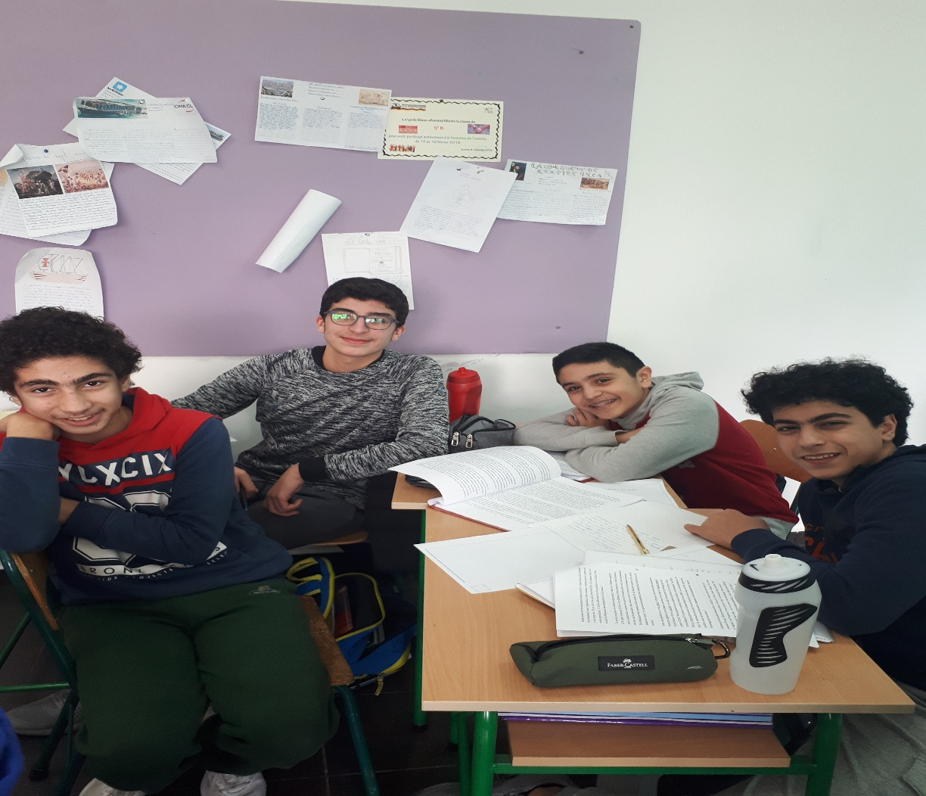

Dear Danish friends,

When we first read an article about Syrian refugees in Lebanon, we weren’t expecting the situation to be this bad and dramatic. We wanted to share with you the crises that are happening in our country.

There are 976,002 Syrian refugees registered in a total of 1, 5 million in the country. The Syrian army occupied Lebanon from 1976 until 2005 but then they were forced to leave, and they called for the Syrians to leave the country as well. Before the Syrian Civil war unskilled, Syrian workers have been in Lebanon since the 1990. At the beginning of the war they brought their families to live with them in Lebanon but then the UNHCR was forced to stop registering newcomers. The rise of unemployment was due to the presence of Syrian refugees.

They began to compete for jobs available to Lebanese nationals in the market. There are 1.5 million individuals out of a population of 4.3 million. Therefore, around 138,000 persons were unemployed. The average of a monthly wage for a Lebanese employee and a Syrian one are very different. The proportion of child refugees working in Lebanon has risen to 7% from 4% in year 2016. In mid-October, 15 buses brought 776 Syrians back to their country. Some Syrians come into the country in order to study. Living in Lebanon is a mix between struggle and joy. They are afraid of being banned from the country, they cannot maintain a bank account. If a Syrian is assaulted o robbed as a Syrian you are not allowed to be a victim and you cannot report anything to the police. If a Syrian dies in this country his or her family will suffer in trying to pay for hospitals. A Syrian said “sending refugees back are literally like sending them to death.”

Our comments on the article:

Some of us are not affected and don’t care about Syrian refugees, and the others are surprised to see the amount of Syrian refugees in the country and the inequality between the Lebanese and the Syrians. Some of us are worried about the crisis because they think they can’t find a solution. The others are confident because finding a solution for this kind of issue is easy.

Questions for you:

1. From which country do the refugees come in Denmark? Are there any Syrians?
2. If yes, how are Syrian refugees treated in Denmark?
3. Are they living in good apartments or in poor refugee camps?
4. Are the refugees accepted in all schools or in special refugee schools?
5. In which means of transport do the refugees come to your country

Waiting to hear from you,

Joey, Magali , Jason & Andreas

Our Instagram :joey.dargham / magzzzooo / Khalilandreas
Our snapshat :blobloco (magali)

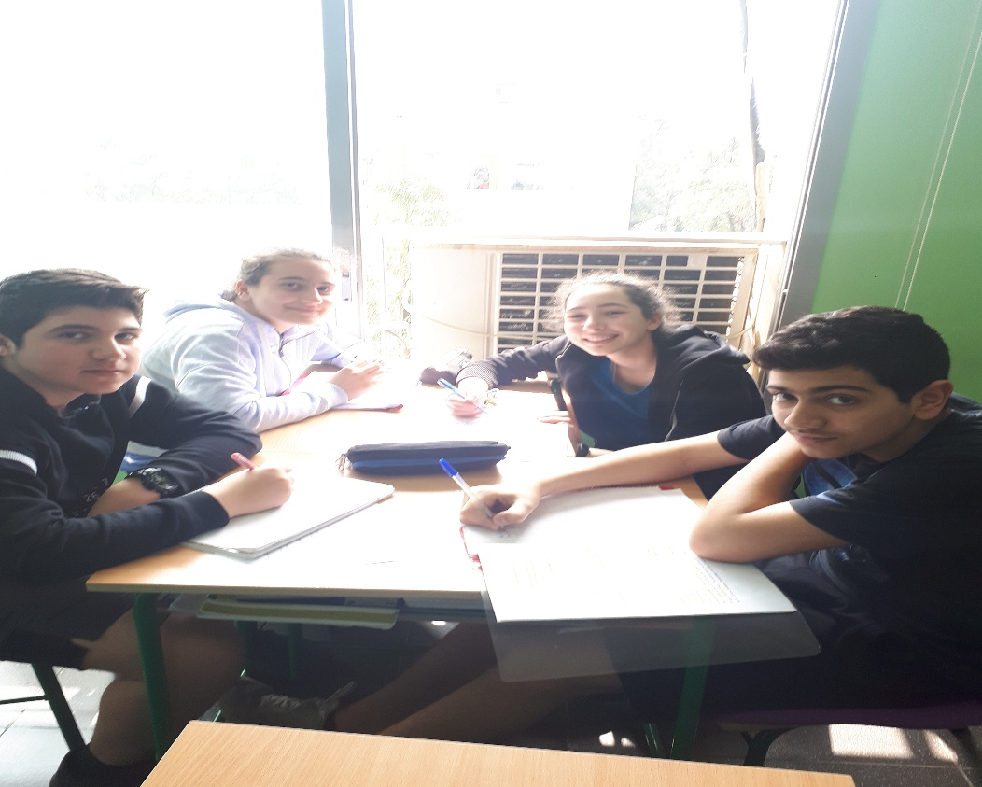

Dear Danish friends,

We have read an article in class about Syrian refugees in our country and wanted to share it with you. So here is a brief summary:

As of October 2018, 1.5 million Syrian refugees were estimated in Lebanon. The war in 2011, destroyed the Syrian citizens. Refugees have been seeking asylum and facing many problems in terms of integration of worse migration because of financial difficulties. From 1976 to 2005, Lebanon was controlled by the Syrian army until the assassination of the prime minister Rafik Hariri; where they were obliged to leave the country. Since the 1990s, low-skilled Syrians were forced to work in minimum-wage jobs, mostly agriculture, before the Syrian civil war. At first, laborers fled to Lebanon accompanied by their families. In 2015, UNHCR (United Nations High Commissioner for Refugees) stopped registering the incomers and Lebanon blocked the borders.
Following June 2018, the presence of Syrian refugees raised unemployment in Lebanon and the Lebanese citizens were fired because their monthly income is much higher than the one for Syrians. As for the Lebanese economy, in the interval of 2007 and 2010, the economy was in prosperity yet succeeding. In contrary, today the economy is in a freefall due to a large number of Syrians working jobs supposedly designated to Lebanese. Moreover, the unemployment rate was raised to a crisis since 2011.

The lives of Syrians are getting harsher day after day, they aren’t protected by the government, children beg for money instead of accessing educational even if a basic one. The access to legal documents, medical car, birth or death certificates is nearby impossible. Almost 200 000 Syrians returned to their country in 2018, claiming the bad living conditions and racism in Lebanon.
A lack of residency status, work limitations or even freedom to move everywhere is withdrawn. Syrians are victim of crime and sometimes accused of committing a crime. They can’t have a proper burial since public and private cemeteries aren’t open to them. What’s going on here is a microcosm of what’s going on all around the world, even the SO said democratic liberal Europe.

Before reading this article, we didn’t know much about refugees in our country not even their numbers and we were worried about our country as Syrians don’t have the necessary documents so they can’t go back to their country without getting caught or arrested. We were shocked when we learned that they were 1.5 million and that our government helps Syrian refugees instead of its own poor and homeless people. We think it’s important to help them because their situation is miserable and hard to live, but we wish that they would leave our country as soon as possible once we help them. And we hope that our country could find the best solution for it.

We would like to know more about the situation of refugees in your country. How many refugees are there? Do you have any associations that could help them? Do they face as many problems in Denmark as they do in Lebanon? Are they equally treated? What about the economy or the unemployment rate after the Syrian war?

Thank you very much for your cooperation. Hope to hear from you soon. And here you could find our Instagrams:
Chiara: chiara.boyadjian8
Jane: janemerhi
Serena: serena_najem_mezher

Hugs and kisses,

Chiara Serli Boyacioglu
Jane Merhi
Serena Mezher Najem

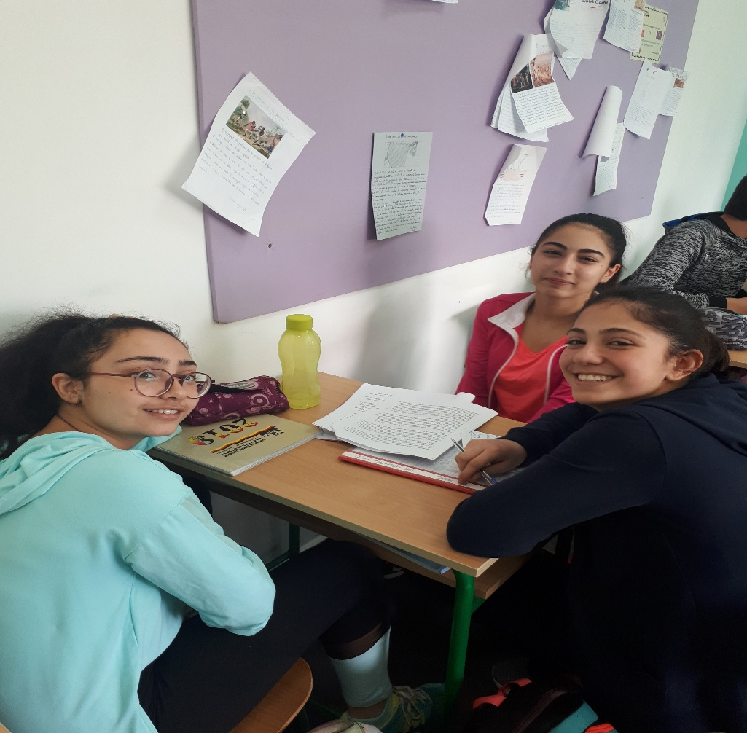

Dear Danish pen friends,

For a while now, Lebanon has been dealing with Syrian refugees who are taking over our country. We, the Lebanese, have to go through the good and the bad consequences. This year we have been participating in a project about refugees with you guys. It has motivated us to learn more about this situation in our country and abroad. We have read an article about Syrian refugees in our country and decided to write a brief summary about it, here it is:

1.5 million Syrian refugees have been seeking in our country, Lebanon when the war first started in 2011. The Office of the United Nations High Commissioner for refugees (UNHCR) registered a big number of Syrian (972,002). The refugees were asked to leave the country with the help of the UN Security Council Resolution 1559 after the shocking assassination of the Prime Minister, Rafik Hariri. In the 1990s the Syrians were employed to work in low-paying jobs such as a driver or a laborer to help their families survive. Due to the war in Syria these families started to move to Lebanon. In 2015, the Lebanese people demanded to forbid these refugees from entering, and then the UNCHR stopped registering newcomers.

The local English-language newspaper announced that the unemployment rate is increasing caused by the presence of Syrian refugees, who are taking over Lebanon. Little by little the Syrians started to replace the Lebanese employees in their jobs. Therefore the unemployment of the Lebanese doubled after 2011 and reached 20 per cent (around 138.000 unemployed Lebanese). The wage of a Lebanese employee is higher ($597) than the Syrians wage ($278), employers mostly higher Syrians. In order to preserve the Lebanese economy the State has recommended sending the Syrians back to their country. A big number of municipalities have set curfews for these refugees; moreover the Lebanese Army expelled them for security reasons. Through the first quarter of 2018, 3664 evictions were identified by the United Nations.
Syrians were publicly called to leave Lebanon by the Lebanese politicians, specifically Gebran Bassil, the Foreign Minister who identifies that the Syrians aren’t refugees but migrants and displaced. Abu Yazan, a Syrian refugee, was attacked and beaten by two men. His wife asking for help was ignored by observers.

When Lebanon tightened the documentation list, the Syrian life became harder as the legal residency permits are an obligation for refugees to stay in Lebanon which costs $200. Thus the Syrian children work with their parents in order to afford paying this permit. The number of Syrian children workers has augmented from 4 % to 7% in late 2016. Sara Khayyali a researcher said: “At a policy, Syrian refugees have difficulties obtaining legal documentation which increase the risk of exploitation by employers and prevents them from accessing medical care. At least 13 municipalities have evicted people just for being Syrian, and they are mostly unable to get civil documentation like birth and death certificates.”
In 2018, 50,000 Syrians returned from Lebanon. 776 refugees were brought back to their country back in mid-October. Ali Khedr, a 27 year-old musician, photojournalist and filmmaker is also the cofounder of a voluntary initiative “Syrian Eyes” he said: “For me, living here is a mix between struggle and joy, if you work hard, you can probably enjoy the good things about this country, but life here is quite difficult for Syrians, Palestinians and even for most Lebanese people because it is a daily struggle to survive.” He then added: “Speaking of rights, you know if you get assaulted or robbed or are victim of any kind of crime, as a Syrian you are not allowed to be a victim and you cannot report anything to the police if you don’t have residency because they will stop you for your residency issue. Another point to be made is also one of the tragic things that people face here is that if a Syrian dies in this country, his or her family will suffer in trying to pay for hospitals and find a spot to bury the dead, as municipalities don’t allow Syrians to be buried in public cemeteries or private ones.” He also spoke about “structural racism through the laws and hate speeches made by politicians and the Lebanese media” he said “adding more burdens on these communities through inhumane and unjust policies will only lead to more instability, hatred and fear of the other, and the many threats of sending refugees back are literally like sending them to death. But I believe that’s what’s going on here is a microcosm of what’s going on all around the world, even in Europe”.

- We have been told that you receive refugees as well. What nationalities are they from?
- How does the government deal with them?
- In our country the government wants the Syrian refugees to leave the country. Is there the same problem in Denmark?
- Do you think that Denmark is going to keep welcoming refugees in your country in the future?
- Are they affecting the employment of the Danish people/workers?
- Is this situation affecting your country in a good or bad way?
- Are they causing any problems in your country? If yes, which ones?
- Is the percentage of refugees entering the country increasing year after year?
- Do you think that they will go back to their own country?

To be honest with you guys, we all knew how bad the situation is but we never knew what the Syrian refugees have to go through on a daily basis. One of the things that struck us is that the Syrians always get blamed for things that they didn’t always do. It is true that they are causing several issues in our country such as the unemployment of the Lebanese people and the over population of the country, but we never cared about the fact that they earn less money when they work. In my vision, they are miss-treated and this is an act of inhumane and unfair. Like the majority of the people, they also go through rough situations, and we never cared or made an effort to help them. Despite the inhumane acts, they have taken over our country in a bad way. What worries us the most is that these refugees will keep entering Lebanon and take the place of all the Lebanese citizens? Moreover they may kick us out of our country if they keep entering Lebanon, who knows what can happen? I think that they should not enter the country anymore but should still be accepted in the other Arab countries as refugees. Then maybe everything will work out. Who knows?

Instagram: mariaafady Snapchat: mariafady Facebook: Maria Fady
Instagram: talia.dah

Regards,

Talia Dahdah and Maria El-Fady

