Refugee Project

8.Z (8.th grade)
Bagsværd Boarding School

Dear students of Deutsche Schule,

We are a group of 3 students from Bagsværd Kostskole & Gymnasium. We’ve read an article about the current refugee situation in Denmark. The article reads that 10.849 refugees got asylum in Denmark in 2015, but in July 2018 it was only 581 people who got asylum. Christian Friis Bach says that it’s because there aren’t a lot of refugees in Europe, because Europe made a deal with the Turkish government, that stops a lot of people from sailing over the Mediterranean Sea. Christian Friis Bach also says that we need to take more UN refugees.

We believe that the refugee situation is very bad. We were torn in the matter. One of us meant that we should help the refugees, but they should go back to Syria as soon as the war is over, unless they want to help Denmark to grow, by working and paying taxes. The state should also be able to punish the refugees harder, if they commit crime. The two other group members meant that it is our duty as fellow humans to help as many people as we possibly can and if they want to stay in Denmark after the war, then they should be able to do so.

We know that Lebanon is right next to Syria, so we are quite sure that the refugee situation in Lebanon is bad, but we don’t know how bad, so we just want to know how the refugee situation is in Lebanon by asking you guys some questions.
How many refugees do you have in Lebanon at the moment?
Do you see a lot of refugees on daily basis?
Do you go to school with any refugees?
How do the refugees live in Lebanon?
Are some of the refugee’s wealthy?

Sincerely,
Frederik, Sarah, Marie

The article we chose:
https://www.bt.dk/politik/dansk-flygtningehjaelp-danmark-kan-tage-flere-flygtninge

Refugees in Lebanon and Denmark – what’s the deal?
Article

Dear students of Deutsche Schule. We’ve read an article about the current refugee situation in Denmark.
The article says:
Something about how many refugees there were in 2015, in Denmark and how many people that requested residence permit. The number has fallen a lot the last couple of years, and that could mean that there is less refugees in the world, but it could also mean that the refugees just go to other countries like Lebanon or European countries.
The writer said that migration is a big subject in families in Denmark and in Christiansborg, where the Danish politicians are.
The politicians really want to solve this problem. The immigrants can request to get reunited with their families, but it was only 3,5 percent of the refugees that got the permit to have their families flown to Denmark. And that is very low.
In 2011 52.000 refugees got residence permit and that was the lowest number yet, because in 2015 85.000 refugees got residence permit, and that was the highest number ever. In the article it says that since 2009 till 2015 there has been a rising number of refugees with asylum in Denmark. In 2015 Denmark hit an all-time high, there was 10.849 refugees in Denmark with asylum. In 2018 there was a significant decline in those numbers, there was only 1.517 refugees with asylum in Denmark, that is about an 9 thousand decline.
We were very surprised because the number has fallen since 2015, and we didn’t think that it would do that. We thought that there would come more refugees for every year. We are also very surprised that only 3,5 percent of the refugees who asked about getting their families to Denmark got their families to Denmark.
We are also a little worried because there is still war and crisis in the world, but Denmark has just become a country that isn’t open for new people, that need help. And then people who really need help just die of hunger or something like that because we won't do anything to help them.
Last but not least we want to ask you some questions about the refugees in your country:
Is the number fallen in your country like it is in our country?
Do you guys see refugees in the streets of Lebanon?
Where are the refugees from, if you have any? (country wise)

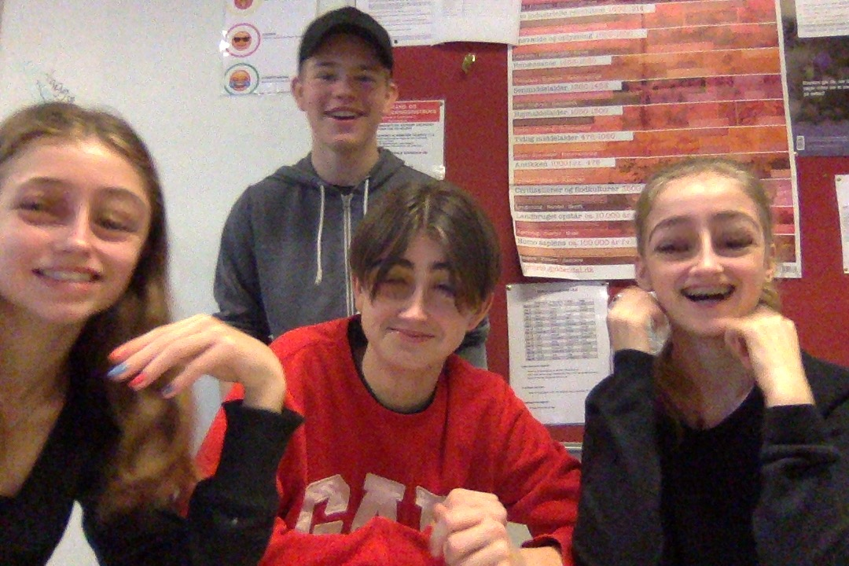
Kind regards,
Jonathan, Ida, Carl and Frida

Dear students of Deutsche Schule,
We are a group of four students from 8.Z. We have worked with the refugee-issue in Denmark, and we found an article about it. Refugees is a big topic in Denmark and it’s something a lot of people talk about. The article tells a lot about how many refugees and asylum-seekers comes to Denmark, and also where they come from. It uses statistics to compare how many refugees Denmark have taken in every year for the last ten years, and shows that Denmark lets fewer refugees in for every year that passes. It also tells that Denmark receives less refugees now than the last few years. Although the numbers have fallen, 18.941 people received asylum in Denmark in 2015. That is the highest number in the last ten years. Denmark rejects a lot of refugees, because they can’t take care of them (the government don’t want to) #saynotoracism. We are just kidding, Denmark doesn’t have the resources to help all the refugees.
Denmark normally provides the refugees roof over their head, education to the kids, and help for the adults so they can learn Danish and find a job.
It also tells that many asylum-seekers wants to bring their families to Denmark.
Many of the asylum-seekers are from the Middle East. But a lot of the immigrants actually comes from Romania, USA, Poland, Germany and India which means that they aren't on the run from their country because of war or other life threatening things. They just want to live in Denmark for other reasons.
We don’t think that our country has found or will find the right solution for either parts - the refugees and the population of Denmark. We have different opinions about what kind of solution there should be, but we agree that the current solution isn’t good enough.
We also have some questions for you guys…
How does Lebanon take care of the refugees?
Do you notice the refugees? or are they just there?
Do you think that your country’s solution is the right one?
Do the refugees get an education and a place to live like in Denmark?
Do the refugees work? are some of them doctors or do they work in drugstores?
Are there any refugees in your school?
Are you friends with any refugees?

So that’s all that we have about the refugees in our country. We are excited to hear about the refugee-issue in Lebanon.

Best regards,
Martin, Sara, Ida and Amalie
Refugee situation in Denmark
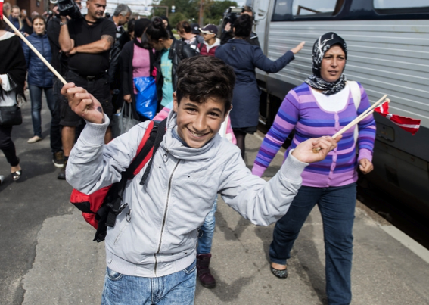
Dear students of Deutsche Schule,
We’ve read an article about the current refugee situation in Denmark. The article reads that the second-generation refugees are becoming more like the Danish people than their parents were. One of the reasons why that is, is because the second generation have been in the country longer than the first generation. The time you have spent in a country has an importance. The refugees are starting to get married later, because they want to get an education, which is very common for Danish people. The second generation are also working more than their parents. Even though the second-generation refugees aren’t working as much as the Danish people, the refugees are certainly improving a lot. The ethnic groups that are most like the Danish society are the Pakistanis and the people from the former Yugoslavia.
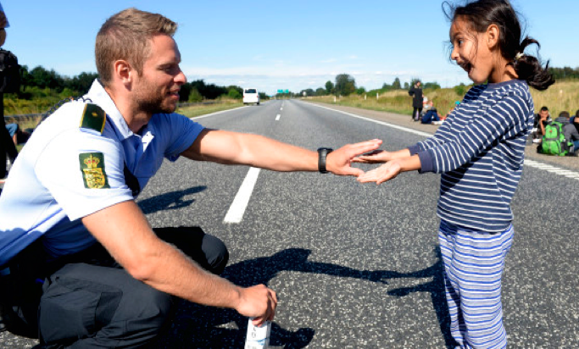
You should look at immigration in a lot of dimensions, then you can get a wider picture of the situation. The Turks and the Pakistanis seem to be very much alike when it comes to the labour market, but if you look at their social capital, the Pakistanis score a lot higher than the Turks. That can help them a lot in their future, where they hopefully are joining the labour market. The surroundings also affect their way of acting. There is a good reason for the fact that the second generation-refugees are getting integrated better that the first generation-refugees. It would be weird if they weren't getting integrated better. The longer you spent time with people the more affected you get of their behaviour. You take over some of their norms, even if it’s good or bad.
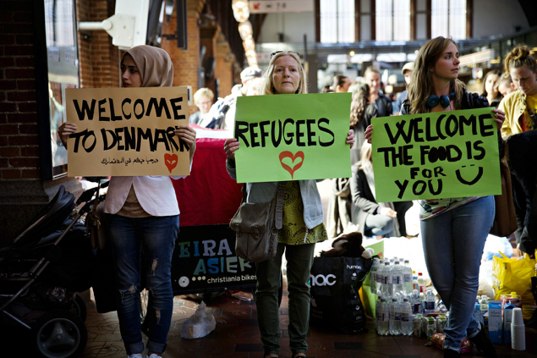
We are happy and proud that refugees are becoming better at joining the Danish society. We also think that it is great that the refugees are working hard and getting educated, because many Danish people think that refugees are lazy and unintelligent. We are not worried about the refugees in Denmark, because the article is very positive and optimistic about the second-generation refugees. When all that is said, we must say that it confidences us that the refugees are starting to act more like the Danes, but still, we are concerned that the refugees will forget who they are and start to become someone they aren’t. Then they’ll get tired of acting and maybe do something stupid to try something new and break their usual behaviour.

Now you know a lot about the refugee situation in our country, Denmark. We would love to hear about the refugee situation in Lebanon. We prepared some questions for you, and it would be great, if you guys would answer them for us.

What do the people in Lebanon think about the refugees, and are the refugees treated equally?
Do the people born and raised in Lebanon have stereotypes of refugees in your country?
Are the refugees in Lebanon beginning to act like the ethnic Lebanese?
Where do most of the refugees come from?
What is your opinion about the refugees in Lebanon?

Kind regards
Carmen, Esin, Inge and Melda

Refugees in Lebanon and Denmark

Dear students of Deutsche Schule,

We’ve read an article about the current refugee situation in Denmark. The article reads that every year the number of refugees in Denmark is falling. In 2015 there were around 11.000 people who received asylum in Denmark. The next year, in 2016 there were around 7.500, and in 2017 there were less than 3000 refugees that received asylum in Denmark.

There are many reasons why there aren’t coming so many refugees to Denmark any more. One of them is that there are coming less refugees to Europe generally. Denmark has also made it very hard for refugees to get asylum because of our tight refugee policy, like our family reunification, permanent residence and the citizenship test. Europa also made a deal with Turkey, that will help to slow down the asylum traffic across the Mediterranean. Because of all the rules, many refugees avoid Denmark and the rest of Europa.

But in principle, Denmark could accept more refugees, because in the past we have helped many refugees from countries like Vietnam, Hungary, and the Balkan area, so we have a lot of experience with that.

We are not worried about the current refugee situation because there is nothing to worry about. The number of refugees is falling in Denmark, and that doesn't surprise us. There are less refugees than there have ever been.
We feel confident that things will be fine, because we trust that Denmark has found a good solution about how to handle the refugee problem.

We would like to hear a little about your current refugee situation, so tell us a little about refugees in your country.
Is there refugees at your school?
How does your country handle the refugees?
Where do they come from?

Kind regards the sweetest girls in our class,

Emilia, Anna SS and Zara

